Woodland Art – Noticing and Reflections
Part 1: Reflect and Respond Critically to the Woodland Art Style (CR 10.2/20.2/30.2)
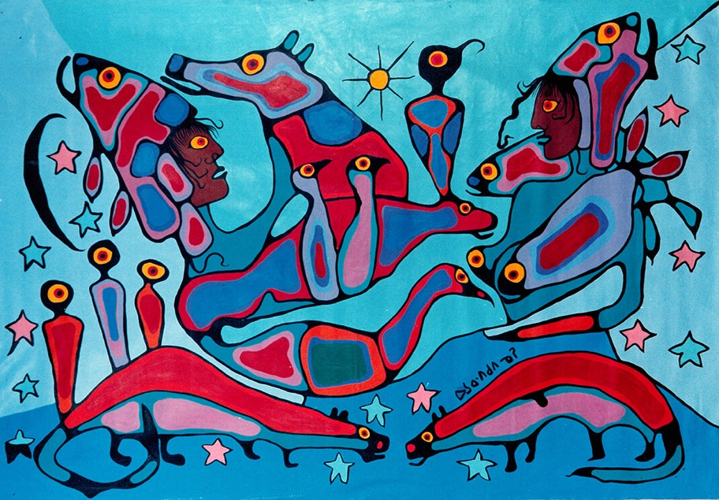
I’m noticing this about the Woodland art style:
Subjects:

Lines:

Colours:

Balance & Unity:

What was the original intent of the Woodland artists in grouping together and creating this style of art?

What is the difference between appreciation and appropriation and why is it important for this project to distinguish between the two?

Part 2: Assess your ability to improve your own art work using self-reflection and peer feedback
(CR 10.1/20.1/30.1)
For this assignment, explain how you used self-reflection to improve your artwork:

What is your painting’s story? Explain.

Review the attached rubric and write below what marks you would give yourself for this handout:
- The mark I would give myself for Part 1 of this handout CR 10.2/20.2/30.2 is: /4
- The mark I would give myself for Part 2 of this handout, CR 10.1/20.1/30.1 is: /4

