Creative Writing 20: Introduction to Poetry
In this unit we will be experimenting with a variety of different types of poetry; most of these poems fall into one of the following categories: Lyric, Narrative, Prose, Found or Dramatic Poems. When crafting our poems we will pay special attention to: focus, word selection, images, rhythm, form, tone, & theme. Revision is an important part of the writing process – we will be sharing our writings with each other and giving one another feedback so that we can improve and polish our pieces.
Throughout this unit students will regularly hand in their notebooks for assessment and feedback, so it is important that everyone complete their assigned poems promptly. We will have a coffee house to share our works. In addition, students are expected to hand in ____ polished, typed, pieces of writing (see rubric) that will be assessed under the “polished pieces” of writing category.

Instructions for Poetry Module
1. Read over this handout and familiarize yourself with the types of poems and review figurative language and the key characteristics of poems.
2. We will be doing class writing exercises daily in our notebooks, the rest of the time will be for students to work through the poetry package independently. Read everything page by page and experiment with all of the following poems and assignments in your notebook:
Lyric Prose continued
Free Verse Parts of Speech Poems (write 2 poems)
Shape Question Poems (do I, II, and III)
Five-Sense Poem (do both sections) Repeat-A-Word Poems (write 2 poems)
Life Metaphors (Do II & III) Series Poems (Do III)
Memory Poems (Do I & II)
In Touch with Nature (Do II) Found
Two-Tone Poetry (Do II & III) Found poem

Narrative Dramatic
Ballad
Fairy Tales Revisited (Do I, II, & III)
Out of a Crowd (Do I & II)
Letter Poems (Do I & II)
Narrative Poetry (Do 1 – 14)

Prose
Autobio-Poem (Do 1 A-C and write your own)
Acrostic
Cinquain (complete 6 poems)
Limerick
Dialogue (Do 1 A-B and write your own)
Notebook Instructions
Label a page in your notebook for each of the above poems (in this same order so that Ms. Gerrard can mark it easily using the notebook rubric and work through them in the same order). You can always tape extra pages in if you need extra space.
*Polished poems must be typed and are assessed separately from the notebook poems. You CAN use notebook poems as material for polished work.
Lyric Poetry
Lyric poetry expresses imagination and emotion. It focuses on individual ideas and experience, and can be written in many different forms, including free verse (most contemporary poetry is written in free verse).
Narrative Poetry
Narrative poetry tells a story using exposition, and often a combination of narration and dialogue. The story may be factual, imagined, humorous, or serious. It may be set in the past, present, or future.
Checklist for narrative poetry: a scene, character(s), & plot sequence of events. The inspiration behind the poetry may be personal, historical, a current event, imaginative, or any combination of these.
Prose Poetry
Prose poetry appears in paragraph form. A prose poem focuses on a singular idea or image, rather than on narrative or series of events that result in some kind of change.
Found Poetry
Students with an interest in popular culture and social issues might be interested in found poetry. Found poems are those which are created from existing material. The author’s role is one of identifying the poem and its meaning, rather than of creating it. Poets find poetry in such unlikely sources as the newspaper, restaurant menus, and graffiti. The poet’s interest is in the language and its meaning in a social context.
Dramatic Poetry
Dramatic poetry is poetry written for performance, and might incorporate the dramatic elements of action and dialogue. Poetry written in the speaker’s diction also fall into this category (i.e. a monologue or spoken word poem). A dramatic poem is meant to stand alone and is not dependent on a larger work for its meaning.
Figurative Language often allows writers to say more with less and often impacts the poem’s tone and meaning.
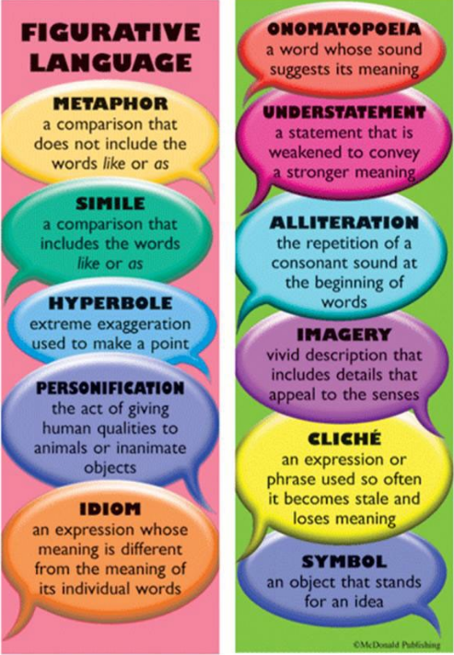
Key Characteristics of Poems - In Creative Writing 20 we will pay special attention to the following in our poetry unit:
Focus
Most poems have a specific focus: a central image, a specific emotion, an epiphany, a revelation, an ironic twist, etc. It is a great challenge to take an idea, find the essence in that idea, and then express it using just the right words.
Words
All writers pay attention to word selection. However, because of the condensed nature and specific focus of poetry, word choice is a primary concern for most poets.
Images
Poems are full of images and it is often an image that is the essence of a poem, or that captures its meaning. Images can be expressed through vivid description. They can also be captured by similes, metaphors, and symbols.
Rhythm
Rhythm refers to a pattern created by words, phrases, pauses, and punctuation. Patterns can be regular, irregular, or random. Rhythm can be both visual (how the words look on the page) and aural (how they sound). Decisions regarding rhythm include:
- Choosing words for their sound in addition to their meaning
- Making choices about line breaks
- Considering pauses
- Considering beat & emphasis
- Making decisions about punctuation
- Matching the poem’s pace to its tone
- Matching the pace to meaning
- Using devices such as repetition
- Working with the natural ebb and flow of the language.
Form
All poetry distinguishes itself through the specific format in which it is written. Many types of poetry are categorized according to the form used by the poet. In addition, some poems take a certain form on the page or form a kind of picture that relates somehow to the content. The most important concepts related to form are the following:
- Form and content are connected
- Form contributes to the meaning of the poem
- In most cases, the content of a poem determines its form
Some form poems have established formulas. These include: cinquains, diamantes, tankas, haikus, etc.) Most contemporary poems are written in free verse, where the lines are not measured or counted for accents, syllables, or rhyme. Lines in free verse may be short, long, or variable. Free verse usually uses vivid images, sound patterns, etc.

Tone
Tone in poetry is the term used for the writer’s attitude toward his or her subject, audience, or self. It is the emotional meaning of the poem and is an important part of the total meaning. For example, is it sarcastic, carefree, happy, angry, or an excited tone? Recognition of tone, on the reader’s part, requires increasing familiarity with word connotation, alertness to nuances of language, and careful study.
The best way in which writers can practise incorporating a particular tone into their poetry is to have readers read the poetry and receive feedback from those readers.
Theme
The theme is a kind of unifying force which keeps the poem from “going off in different directions”. The theme of a poem is not its subject, but rather its central idea, which may be stated either directly or indirectly.

Revision Questions
Basic questions writers might ask themselves, after they have completed their first drafts, include the following:
- Is the focus clear?
- Does the poem explore or shed light on my ideas or question?
- Are the images and descriptions interesting and convincing?
- Are all the words exactly the right ones?
- Does the poem display originality?
- Does the poem have the impact I hoped it would?
- Am I satisfied with the rhythms when I read the poem aloud?
- Is the poem punctuated in a way that contributes to the rhythm?
- Are the lines broken in the right places?
- Is the form effective?
- Does the form reflect the subject matter or content?
- Is the structure appropriate, and does it allow for meaning to be revealed as I wish it to be?
- Is the theme focused?
- Have I created the best possible ending or last line for my poem?
- Did I spell everything correctly?

