Reduction Linocut Method Step by Step
Copied from: http://nataliamoroz.com/reductionmethod.html
Reduction method is a printmaking technique when a multicolored print is made with the use of a single block. Through a series of progressive cuttings, inkings, and printings, the image slowly emerges while the actual block is destroyed. A reduction print can therefore never be reprinted. The main advantage of reduction method is perfect registration.
Reduction method can be tricky, but planning ahead makes it much easier. I always start with a detailed tonal value drawing (preferably in color). Usually, reductions are printed from light to dark.
Here are step by step images of my recent 5-colors linocut "Breaking Waves". Carved from unmounted Golden-Cut linoleum. The image size 8"x12". Printed on Rising Stonehenge paper with Daniel Smith oil based printing ink.
1.
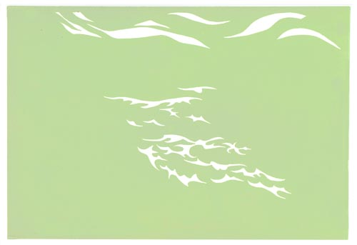
The drawing was transfered to the linoleum block. I started with carving away all areas that shall remain white in the final print (white clouds and foam). The plate was printed in pale yellowish green ink.
Tip: When printing a linocut with more than one layer of inks, I remove extra ink from paper by pressing a clean sheet of plain paper against a freshly printed image. It illuminates unwanted shine and improves the coverage of subsequent layers.
2.
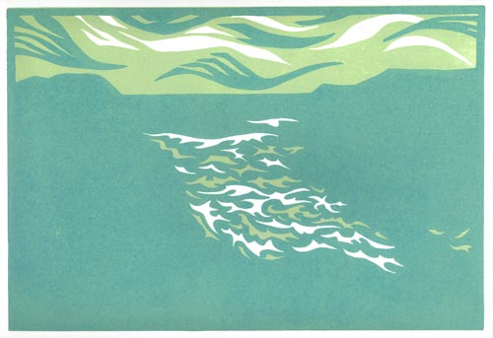
After the first layer of ink dried, I carved the plate some more and removed the areas that had to be left in the pale yellowish green (parts of the sky and waves). At this state, the plate was printed in teal color.
3.
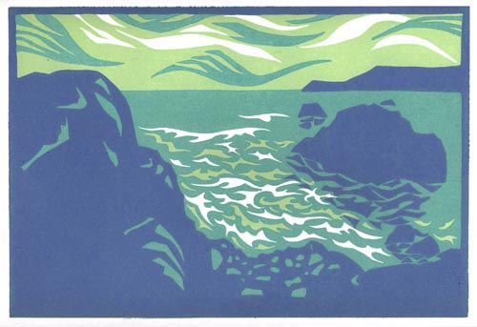
Then the plate was carved some more. Everything that need to be left in teal color (dark clouds and most of the ocean surface) is cut away. Then the plate was printed in light blue.
4.
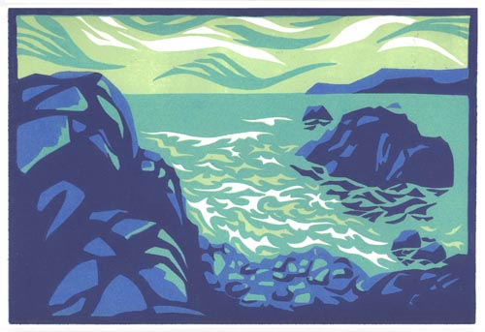
Everything that had to be left light blue is cut away (rocks on the foreground and background). Then the plate was printed in muted violet ink.
5.
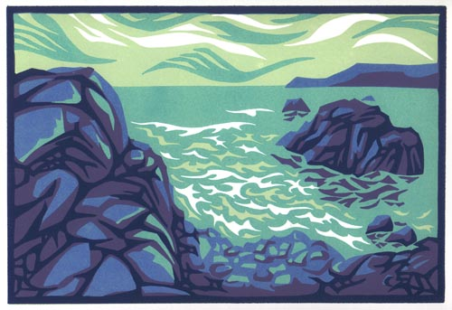
Finaly, I carved away everything that had to be left dull violet. The plate was printed in dark blue.

