Creative Writing 20 – Multi-Genre Paper
For this assignment you will be putting together a collection of your work around a central theme. You can pick the theme, and what work you include. Choose work that shows your diversity as a writer, and that showcases your talents.
You must include work from 2-3 genres (minimum):
- Poetry
- Short stories
- Scripts
- Non-fiction
You need to include 5-6 pieces of work, but they don’t necessarily have to be work you’ve done in this class. Pick your favourite pieces of writing and showcase your talents.
Requirements:
- Create a cover page that entices me to want to read your work.
- Create a “Dear Reader” page that tells me about your topic and why it’s important to you, or why you chose it. This gives me a quick overview of your project. Here is an example:

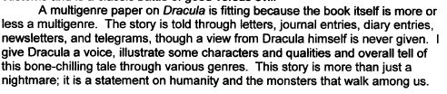

- Include 5-6 works from 2-3 genres, one work per page unless you’re using more than one for impact.
- Create a “Notes” page that lists the page number for each work and explains why you included it. Here is an example.
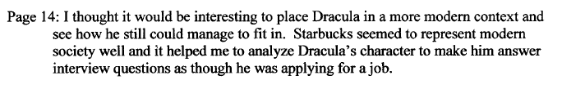
- Complete the self-reflection.
This project is due on the last day of classes – JANUARY 21 – it cannot be late! I will return your multigenre project to you on final exam day (Thursday, January 24) where we will have a class coffeehouse and participate in reading a selection of your works.

