Song-writing in ten steps
paraphrased from the songwriting videos on Ms. Gerrard’s weebly
1. Write about what you know
2. Choose a musical key to write your song in. “How to Write a Song” specifies how the C Chord (
Notes | C | D | E | F | G | A | B | C
Chord | Major | Minor | Minor | Major | Major | Minor | Diminished
Chords by roman # | I | ii | iii | IV | V | vi | vii
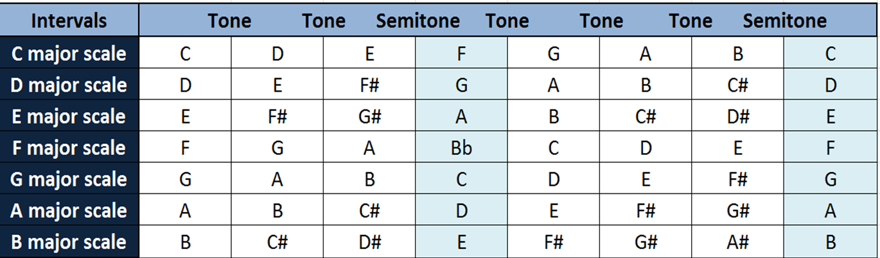

3. Write the chorus
4. Write the story that makes up your song. Think beginning, middle, end.
5. Write the bridge (this can be a departure from the song’s melody)
6. Evaluate and refine the song’s rhythm. Pay attention to the amount of syllables and rhyming nature. Most songs use parallelism in their verses (similar amount of syllables work with the beat) and most rhyme at least half the time (too much rhyming = cheesy, no rhyming = loss of rhythm)
Verse
Pre-chorus
Chorus
Verse
Pre-chorus
Chorus
Bridge
Chorus

7. Stay on one topic
8. Choose your structure. If you’re starting out, stick with predictable structures such as:

9. Keep the whole song under 3:20. Most radio stations cut songs to this length. Too long = boring. Shorter = flashy.

10. Advertise the song. In this case, Ms. Gerrard would love to hear a rendition, so practice and perform it!

