Green Screen: Adobe Premier Pro Tutorial
- Click “Start” “All Collections” “Adobe Master Collection CS6” and select “Adobe Premier Pro”
- Click “New Project” and “OK” “OK” (x2)
- “File” “Import” and click on the following:
  - Media Drive
  - Class Assignments
  - Communications Media
  - Media 10
  - 03 Keying + Mattes
  - Green Screen Footage
- Click on Green Screen video “open” and click and drag the video to “Video line 2”
  - Click “Video effects” and “Keying”
  - 8 point garbage matte
  - Click and drag until is on top of the green screen
- In the upper left box is the “Effect Controls” box
- Click on the rectangle eight point garbage (should show up on the right)
  - Click arrow tool and drag so that the selection only shows the green screen
- Click “Chroma Key” and drag and drop as well
  - Using eye dropper select the green hue
  - Click on similarity and drag over until the green is all keyed out
- File Import (it should default to the media 10 folder) “261_JB” and drag it under Video 1.
Green Screen: Photoshop Tutorial
- Google a Model with a green screen background, save it to your computer and open the image in Photoshop.
- Click “Select” & “Colour Range.” Select a mid-level green. Make sure it’s inverted so the background is black. Bring the fuzziness range almost all the way to the top. Click “OK”
- On the control panel, click “Layer Mask” and the green background should disappear.
- If there is any fuzziness where perhaps some of the model has disappeared, click on the thumbnail layer mask and press “ALT” at the same time. Select the dodge tool and make sure the setting is on “Highlights” and dodge the area where it is fuzzy. This will make your image completely black and white and add details back to your model. Click on the layer thumbnail and simultaneously press “ALT” again to bring the image of the model back.
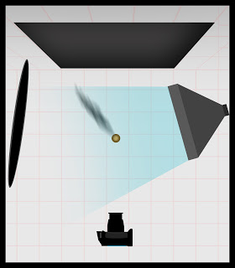
- Google a background image that will exist in the background, save it to your computer and open it in the same Photoshop document as a layer under the green screen model layer. Press “Control & T” to free transform it and resize it to the dimension you want. Press Enter when you are happy with it.
Lighting in the Studio for Green Screen Photography: Use the diagram pictured right to ensure that you light your subject the best possible way to make sure your chromakey job is on the easier side.

