Saskatoon gay couple 1st to be married in Mennonite church
Craig Friesen and Matt Wiens were married on New Year's Eve
By Rachel Bergen, CBC News Posted: Jan 05, 2015 5:30 AM CT Last Updated: Jan 05, 2015 7:46 PM CT
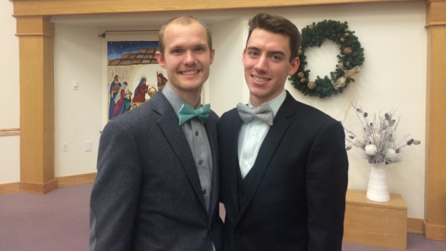
Craig Friesen, left, and Matt Wiens, right, were married by the pastors of Nutana Mennonite Church (where they currently attend) in Osler Mennonite Church, the church Friesen grew up attending. (Rachel
New Year's Eve is a special time for many, and for Craig Friesen and Matt Wiens, it was especially meaningful.
The Saskatoon couple was married on Dec. 31 in Osler, Sask., in the presence of family, friends and the church community.
The men's wedding marks a point in history for the Mennonite denomination in Canada. Friesen and Wiens are the first same-sex couple publicly married in a Canadian Mennonite church.
"Our relationship doesn't feel different, but our relationship with our community and with our faith has changed at least a little bit. It was really beautiful and freeing," Friesen said.
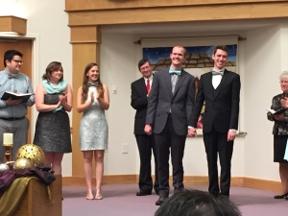
Craig Friesen and Matt Wiens were married on New Year's Eve. (Rachel Bergen/CBC News)
​Friesen and Wiens are hopeful other LGBT Mennonites will learn from their example that they don't have to choose between their faith and their sexuality.
"Historically, the church has been oppressive to the queer community," Wiens said.
One step forward
For Wiens and Friesen, it was important to have a Mennonite wedding, because it was the faith the men grew up in.
"For us, a wedding is supposed to be a celebration of our commitment to each other in front of our faith communities, our other communities and God," Friesen said.
"It wouldn't feel right if we didn't get married in the Mennonite church," he added.
Mennonite Church Canada as a denomination isn't publicly welcoming of LGBT people or affirming of same-sex marriage. The denomination's confession of faith states that marriage is between a man and a woman for life.
Last year, however, the governing body in Saskatchewan announced that congregations could decide on their own whether or not they would be welcoming and the church would not take action against it. This was decided, in part, to keep some congregations from leaving the denomination.
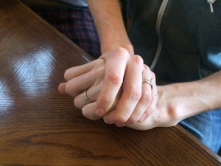
Craig Friesen and Matt Wiens proposed to each other last year. (Rachel Bergen/CBC News)
​Friesen and Wiens attend Nutana Park Mennonite Church in Saskatoon, which has been publicly inclusive of the LGBT community for three years.
Co-pastors Anita Retzlaff and Patrick Preheim married the couple in the church Friesen grew up in, Osler Mennonite, combining both the church communities that mean so much to them.
It was a bold move for the two pastors, who said there are vocal Mennonite congregations across the country that don't agree with gay marriage.
'More work to do'
The newlyweds hope their wedding will inspire hope in LGBT people and mend some of the relationships between lapsed LGBT Christians and the church.
"Having these examples that someone doesn't have to choose between their religion and who they're attracted to, I think that's important," Wiens said.
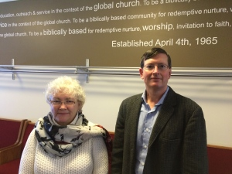
Anita Retzlaff and Patrick Preheim are co-pastors at Nutana Park Mennonite Church in Saskatoon. (Rachel Bergen/CBC News)
Preheim hopes the steps Nutana Park Mennonite Church has taken will start important conversations within congregations.
"I do not know how other congregations that are a part of Mennonite Church Saskatchewan will respond. For some it could be a stretch, and there may be some conversations that happen, but hopefully the conversation will be civil and we'll be able to listen to each other," Preheim said.
Retzlaff said there's a long road ahead, but she hopes vulnerable LGBT people will find refuge in Mennonite churches.
"I'm hoping that they feel there are places that welcome them with open arms and that the church can be a word of reconciliation and love instead of exclusion and anger. The church has a great deal of work to do and I'm hoping this is one step toward a much better relationship," Retzlaff said.
http://www.cbc.ca/news/canada/saskatoon/saskatoon-gay-couple-1st-to-be-married-in-mennonite-church-1.2888826

