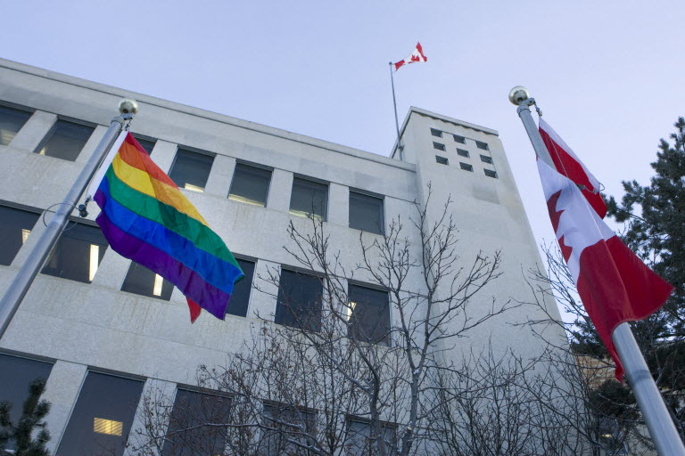
The rainbow-coloured gay pride flag was flying Feb. 11, 2014, at city hall and was to run throughout the Winter Olympics.
Photograph by: Richard Marjan , The StarPhoenix
The rainbow-coloured gay pride flag was flying Tuesday morning at city hall and will stay there throughout the Winter Olympics.
City council voted at Monday's meeting to fly the flag.
Although the motion to fly the pride flag was not debated, other municipalities in Canada and the provincial legislature in Regina have hoisted the pride flag to express support for gay rights in light of Russian laws that are deemed to suppress gay rights. The Winter Olympics are being hosted in Sochi, Russia.
The laws restrict pro-gay "propaganda" that could be accessible to minors, though critics say it has the widereaching effect of preventing any expression in favour of gay rights.
Saskatoon follows Edmonton, Calgary, Vancouver, Montreal and other Canadian cities in flying the rainbow flag - a symbol of lesbian, gay, bisexual and transgender rights and pride.
Atchison said raising the flag is an important symbol of solidarity.
"This is about human rights ... Here in Saskatoon we are an open and embracing and inclusive community," Atchison said.
Despite his commitment to raising the flag this week. Atchison has been criticized in the past for not attending Pride Week - a weeklong event celebrating LGBT issues. Since he was first elected mayor in 2003, Atchison has yet to attend any Pride Week events.
Last year, Atchison was out of town during Pride Week, attending the World Cities Summit Mayors Forum overseas.
A representative from the mayor's office said he hasn't seen the schedule for Pride Week this year and could not confirm whether or not the mayor will attend.
A number of city councillors expressed their support for the move prior to Monday's meeting.
While Coun. Pat Lorje supported the pride flag, she expressed concern about the lack of rules regarding raising a flag at city hall.
"We need to have a clear process for flag flying," said Lorje. "We need a proper protocol on this one."
-with files from Charles Hamilton

